PRODUCT NAME: | MOC Strawberry Gateau Solid |  | 
PRODUCT CODE: | F01010
MANUFACTURER  CONTACT DETAILS: | Ministry of Cake Ltd, Frobisher Way, Bindon  Road, Taunton, Somerset, TA2 6AB
GENERAL DESCRIPTION OF PRODUCT:
A two layer gateau made with stabilised dairy cream and strawberry filling layered between light textured vanilla sponges and decorated with stabilised cream rosettes and strawberries covered in a strawberry sauce. Side decorated with peanuts. Solid.
INGREDIENTS: Stabilised Cream [Dairy Cream (Milk) (19%), Water, Dextrose, Sugar, Glucose, Dried Buttermilk, Stabiliser (E407)], Sugar, Strawberries (12%), Wheat Flour (with Calcium Carbonate, Iron, Niacin, Thiamin), Water, Whole Egg, Strawberry Jam (7%) [Glucose-Fructose Syrup, Strawberries, Gelling Agent (E440), Acidity Regulators (E330, E331), Colour (E163), Natural Flavouring , Preservative (E202)], Peanuts (5.5%), Strawberry Puree (3%), Glucose Syrup, Modified Maize Starch, Raising Agents (E450i, E500ii), Skimmed Milk Powder, Whey Powder (Milk), Wheat Flour, Emulsifiers (E471, E475), Modified Potato Starch, Natural Flavouring, Acidity Regulator (E330), Colours (E163, E161b), Stabilisers (E415, E412), Dextrose.

ALLERGY ADVICE:
* Allergens in the ingredients list (including cereals containing gluten) are shown in Bold. (Allergens not highlighted in bold are NOT present).
* Allergens NOT present in any of our MOC recipes include: Celery, Crustacea, Fish, Lupin, Molluscs, Mustard and Sesame.
* May contain traces of nuts. (Contains Peanuts). (Nuts are used in manufacturing and on packing lines so there is a small risk of cross contamination.
* Egg, milk, soya and sulphites are only present if highlighted in CAPITALS in the ingredients list, otherwise they are not present.
* Suitable for vegetarians.
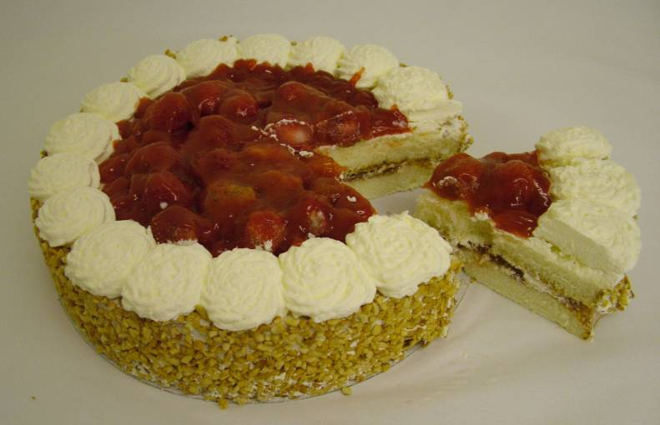 |  | 
STORAGE INSTRUCTIONS:
Commercial / Food Freezer (-18ºC) **** Until Best Before Date
Star Marked Food Freezer (-18ºC) *** Until Best Before Date
Compartment (-12ºC) ** 1 Month
(-6ºC) * 1 Week
Ice Making Compartment (-6ºC) 3 Days
Refrigerator (5ºC) 24 Hours
Consume on day of purchase if not kept chilled / frozen.
IMPORTANT - DO NOT REFREEZE AFTER DEFROSTING
DEFROSTING AND SERVING INSTRUCTIONS:
HANDLING GUIDELINES FROM FROZEN: For best results remove all packaging whilst product is still frozen and place on a serving plate. Defrost for approximately 6 hours or overnight in a refrigerator at 5°C. Alternatively remove the required number of slices from frozen product and defrost each slice on a plate at 5°C for approximately 2 hours. Once defrosted store in a refrigerator (5ºC) and consume within 24 hours.
NUTRITIONAL INFORMATION: TYPICAL VALUES PER 100g AS SOLD:
Energy 1102kJ / 262kcals, Fat 10.9g, of which Saturates 5.4g, Carbohydrate 36.7g, of which sugars 25.5g, Protein 4.4g, Salt equivalent 0.38g.
Sodium 0.15g

Fibre 1.22g
Calculated 15.3.17 using QSA Software.

Sodium 0.15g (Analytical tested 4.4.17)
Salt Equivalent calculated from sodium x 2.54. Analytical tested 4.4.17
Kosher Certificate
Not applicable – not certified
Halal Certificate
Not applicable – not certified
GM
Not manufactured with GM materials.
Country of Manufacture:
Produced in the UK but using ingredient from various origins
Shelf life:
24 months from packing. Delivery shelf life 75%.
Packing Format
Cases: 8
Layers: 5
Units per outer: 6 x 1 unit
Cases per Pallet: 40
Barcode:
Inner: 05010823100264
OUTER: 05010823510032
BBE AND JULIENNE CODING:
Example: JAN 18 L6030 10:19
BBE (JAN 18) (First 3 letters of month; last 2 digits of year) Lot Number: (L6030) L (lot number) 6 (Year manufacture) 030 (Day of Year) 10:19 (Time – 24 hour clock
PACKAGING: Primary packaging complies with the Materials & Articles in Contact with Food Regs.
HEATH MARK: None
Target Product Weight per Unit (Inner)
1081g ± 87g
No net or average weight declared on packaging.
Completed by: Susanne Hayes (Product Specification Manager)
Date: 4th April 2017

Changes Register
Version Change | Date | Changes Made | Initials
1 | 21.07.2011 | 32% cream change | AK
2 | 20.2.2013 | FIR legislation for label – product updated | SH
3 | 24.09.14 | Added FIR wheat additives, barcodes, allergy statement, Halal, GM, Kosher status. | SH
4 | 03.02.2016 | Minor updates; delivery shelf-life, julienne code, food contact packaging | SH
5 | 15.3.17 | Nutritional recalculated on QSA, salt to be sent for analytical testing (DM) | SH
6 | 4.4.17 | Analytical sodium & salt added | SH

